Snowmobile
Heated Shield Outlet Kit
Installation Instructions
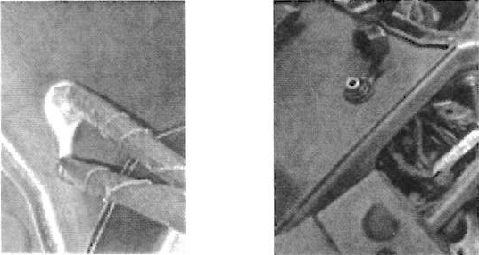
Please read instructions before beginning the installation of Heated Shield Outlet
Kit includes:  1. Remove both side access panels, hood, and seat.  2. Removing the two quarter tums securing that lower console panel to the machine.  3. Then using a 3/8-in(9.5mm) drill bit, drill hole approximately 1” in from right edge and 2” from top of console panel. See Fig.1 for mounting location.  Fig.1  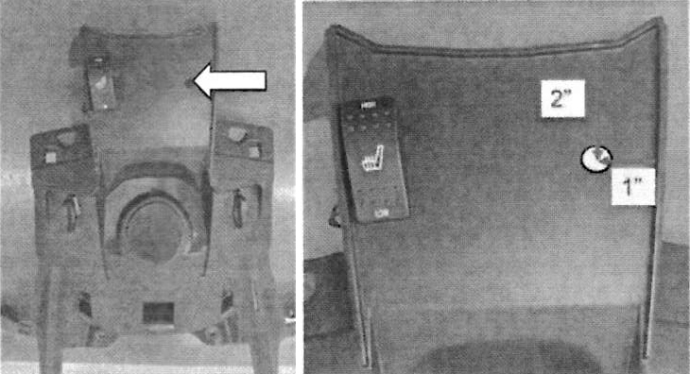  4. Install the round terminal over the outlet end  of harness. See Fig 2.  5. Install outlet through hole created in the lower console panel next install protective outlet cover over the outlet  and secure to the console using outlet retaining nut.  Insuring not to over-tighten the nut. See Fig 3.  Fig.2 Fig.3 | 6. Connect the harness to machine wire harness  with connector near the right-side footrest.  7. Secure outlet harness using cable ties.  See.Fig.4.  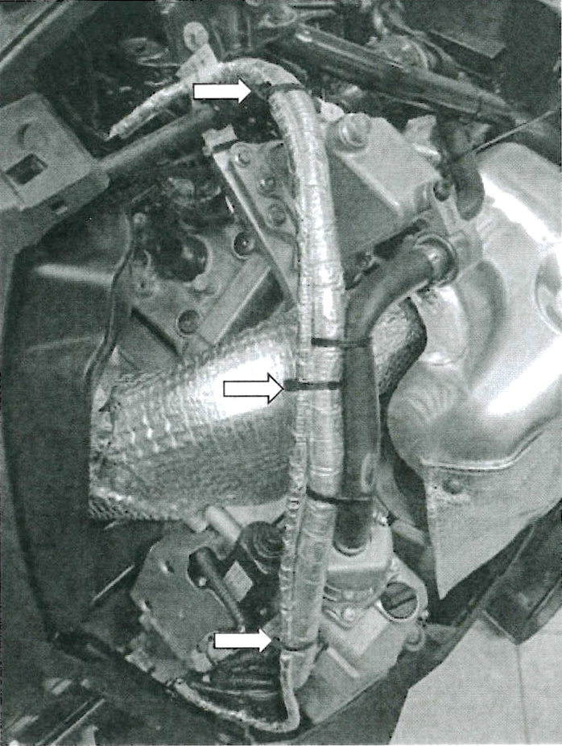  Fig.4  8. Reinstall lower console panel; followed by reinstallation of the hood and side panels.
  QTY | DESCRIPTION
  3 | Cable Tie
  1 | Outlet Retaining Nut
  1 | Protective Outlet Cover
  1 | Outlet Harness
  1 | Instructions

